Application Name : Zonions Restaurant Application

Date: 16/12/2020

Technology Used: -Reactjs,Sailsjs,Nodejs,MongoDb

Step: 1 – This is my Restaurant home page look like this

In this, home page there is Home button and Login button will be provide from the navbar and under the Restaurants table, there is new record will be display , and this record already present in the database that’s why display the data from the home page .

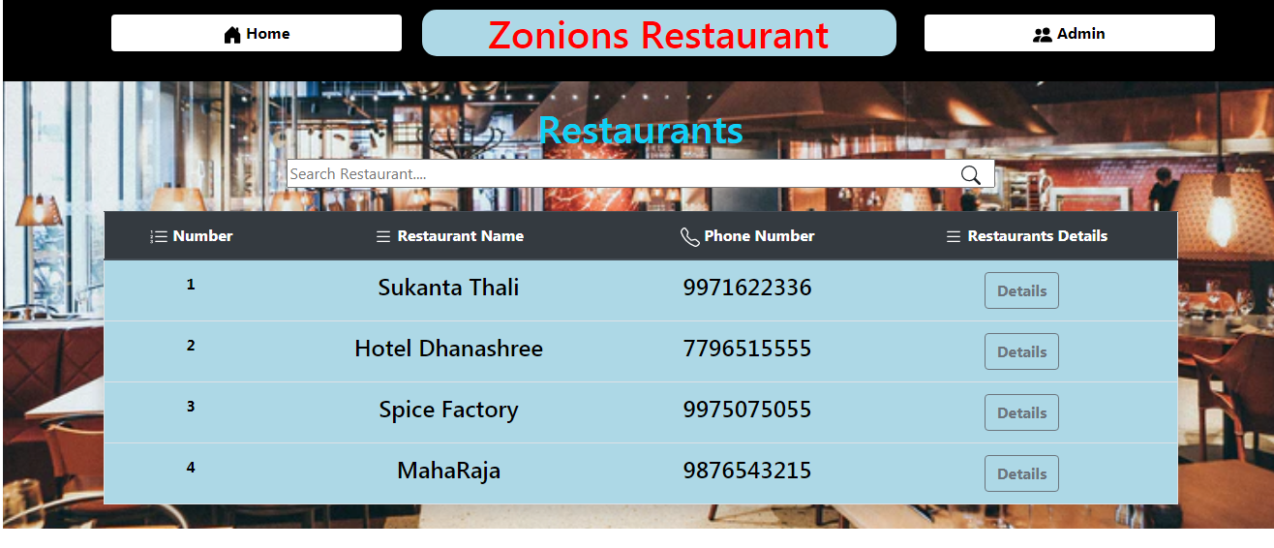

Step:2 –Click on view button

Click on view button then to get the all details of restaurants. Then click the back button the control goes from the Home page.

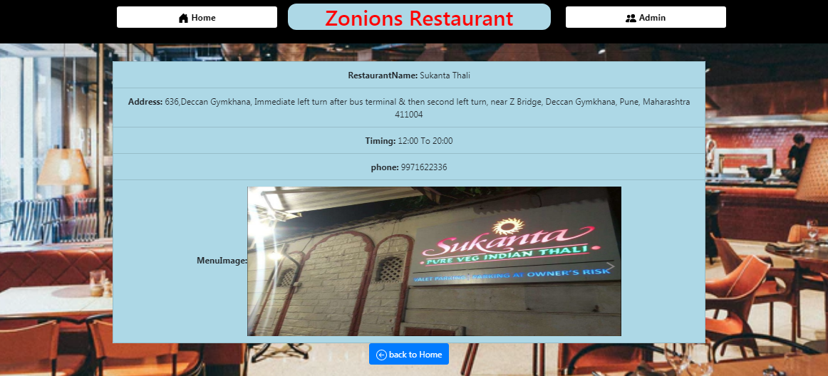

Step 3 – Click on login button then enter the above credentials

Username =admin & password =admin then username and password is correct then above image will be open

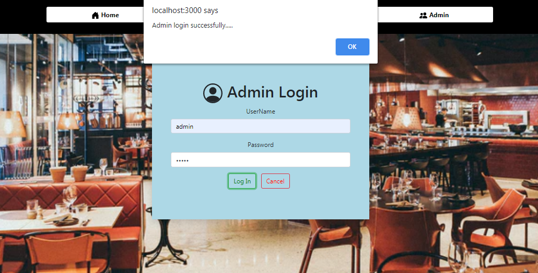

Step 4 –Login success then admin management page will be display

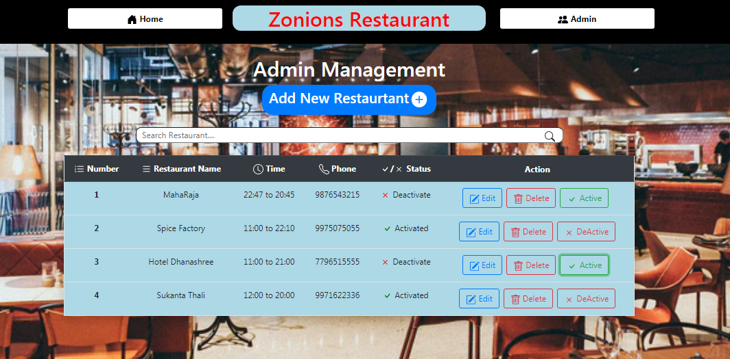

Step 5 –Admin can add new restaurant then click on [Add new Restaurant] button then admin can add the new Restaurants see the above image.(This form are provided all the validation from the input field that’s why please enter valid data similar as the bellow example otherwise you will get the error .)

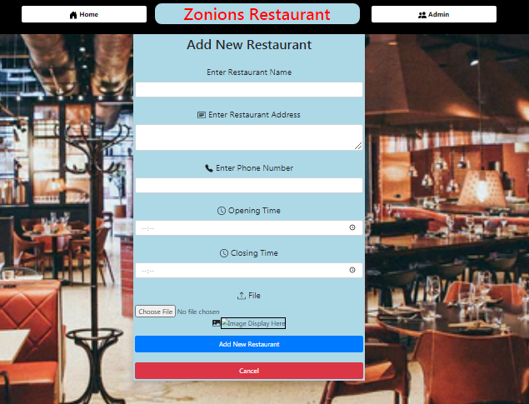

Step 6 –Click on Add New Restaurant button then record will be added in the database and new record will be display from home screen as well as Admin management screen.



Step 7 – Admin can edit the particular record then to update the data from the management table and, also home page from the application.

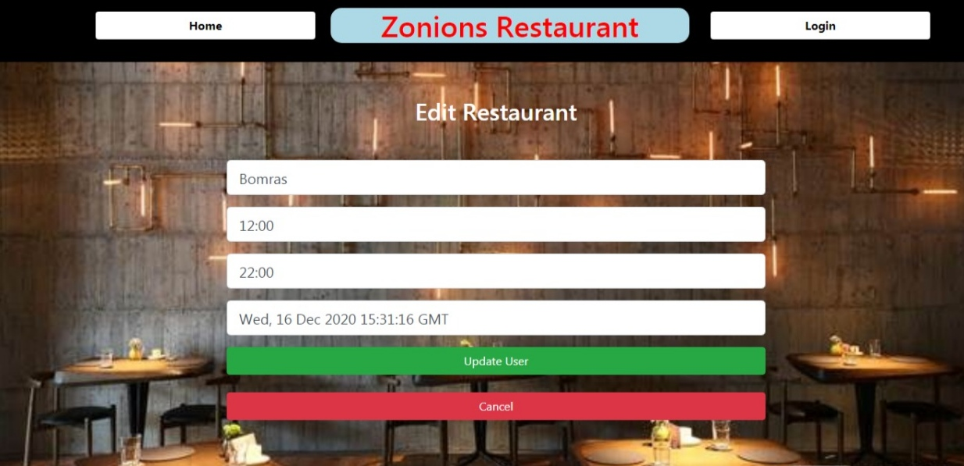

Step 8- Admin can click Delete button first confirmation will be there (Are you sure want delete this record) admin can click ok, and then record will be deleted succeffully .and back response from admin management page.

Step 9- admin can be added 100 records then record can easily find out that’s why used search bar is provided.

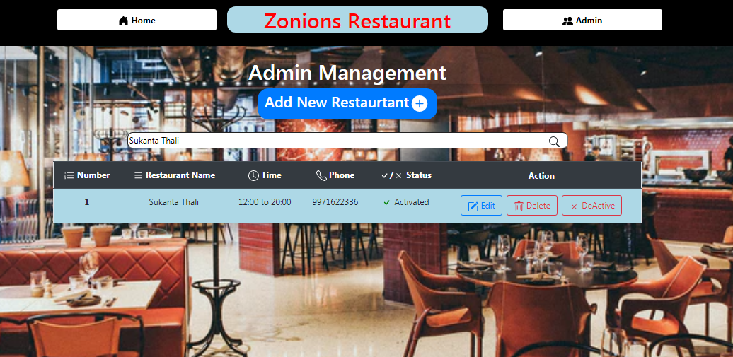

Step 10 – Admin can click home button then control goes from home page and then repeat process from the step-1 to step -9.

**Rest Api's :-**

1. Add Restaurant :- 'POST /restaurtantDetails': 'RestaurtantController.create',

2.Get All Restaurants :- 'GET /restaurtantDetails': 'RestaurtantController.find',

3.Update Restaurant :-

'PATCH /restaurtantDetails/:id': 'RestaurtantController.updat',

4.Delete Restaurant :- 'DELETE /restaurtantDetails/:id': 'RestaurtantController.delete',

Thank You.